Istituto Comprensivo

**San Costantino Calabro – Mileto**

**INVITATION LETTER**

On behalf of our school, The Istituto Comprensivo from San Costantino Calabro (Italia), in the frame of the ongoing Erasmus+ project, we extend an official invitation to Partners to participate in a job shadowing experience, based on exchanges and activities to improve skills and knowledge regarding the Erasmus+ coordination.

This event is scheduled to take place in San Costantino Calabro (VV), Italia, from 26th of June to 28th of June 2025.

The program will be built in the context of the topic: "Exchanging best practices in Erasmus+ program management - upgrading partners' skills".

Provisional programme :

1. Exchanges between partners, students and teachers: meetings, conferences, workshops.

2. Pedagogical activities regarding digital skills and IA.

3. Erasmus+ management: programs, coordination, difficulties and solutions.

Should you need any further information regarding the seminary, please do not hesitate to contact Eduardo Rubio or Guillaume Delhommeau, Erasmus+ coordinators.

Yours sincerely.

|  |  |
| --- | --- |
| **Eduardo Rubio Nubla**  **Coordinador Erasmus+ Colegio Nuestra Señora del Huerto**  **P +34 659621311**  **W** [**https://www.colegionshuertopamplona.com**](https://www.colegionshuertopamplona.com/)  **E eduardorubio@nshuerto.org**  **E coordinadorerasmusplus@nshuerto.org**  **A C. del Monasterio de Urdax, 25, 31011 Pamplona, España** | **Guillaume Delhommeau**  **Directeur Délégué aux Formations Professionnelles**  **P h+33 243 501 237 M +33 684 196 968**  **W** [**https://funay-boucher.paysdelaloire.e-lyco.fr/**](https://funay-boucher.paysdelaloire.e-lyco.fr/)  **E guillaume.delhommeau@ac-nantes.fr**  **A 22 Rue Rodolphe Diesel, 72100 Le Mans - France** |

**ERASMUS+ PARTNERS SEMINARY -** Logistical aspects of the seminar

WHERE

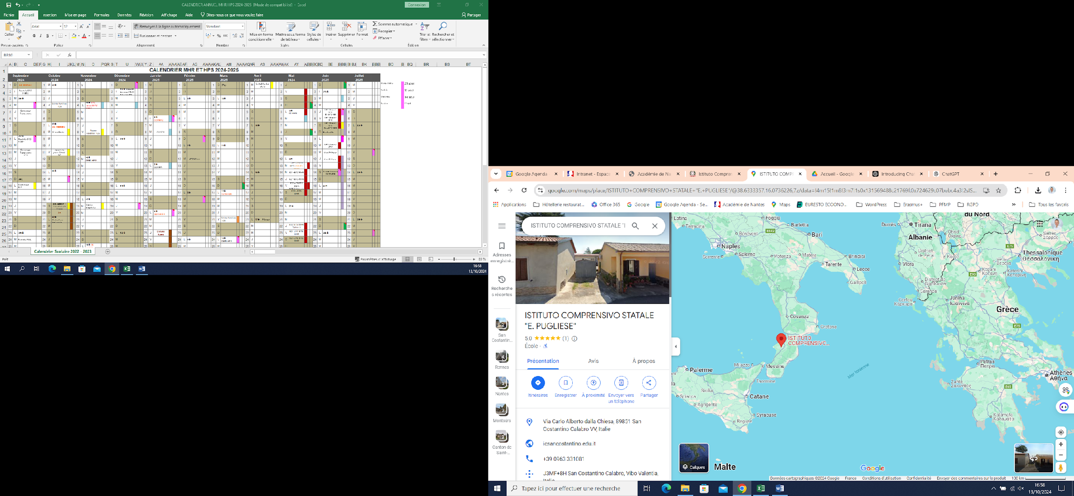

Istituto Comprensivo San Costantino Calabro-Mileto

Via C.A. Dalla Chiesa, 89851- San Costantino Calabro (VV)-

Site Web: <https://www.icsancostantino.edu.it/>

MAIL: [vvic81200v@istruzione.it](mailto:vvic81200v@istruzione.it)

Pec: [vvic81200v@pec.istruzione.it](mailto:vvic81200v@pec.istruzione.it)

Principal: Luisa Vitale, portable (+39)3387350741

mail: luisa.vitale@icsancostantino.edu.it

Erasmus+ coordinator : Tiziana Rubino

Portable: (+39)3476244619.

Mail: tizianarubino72@gmail.com

Teacher in charge of Erasmus+ activities: Marianna Scarcia

portable: (+39) 3282329598

Mail: marianna.scarcia@icsancostantino.edu.it

WHERE

**Airport :** Lamezia Terme (30 Kilometers) or Reggio Calabria (100 kilometers)

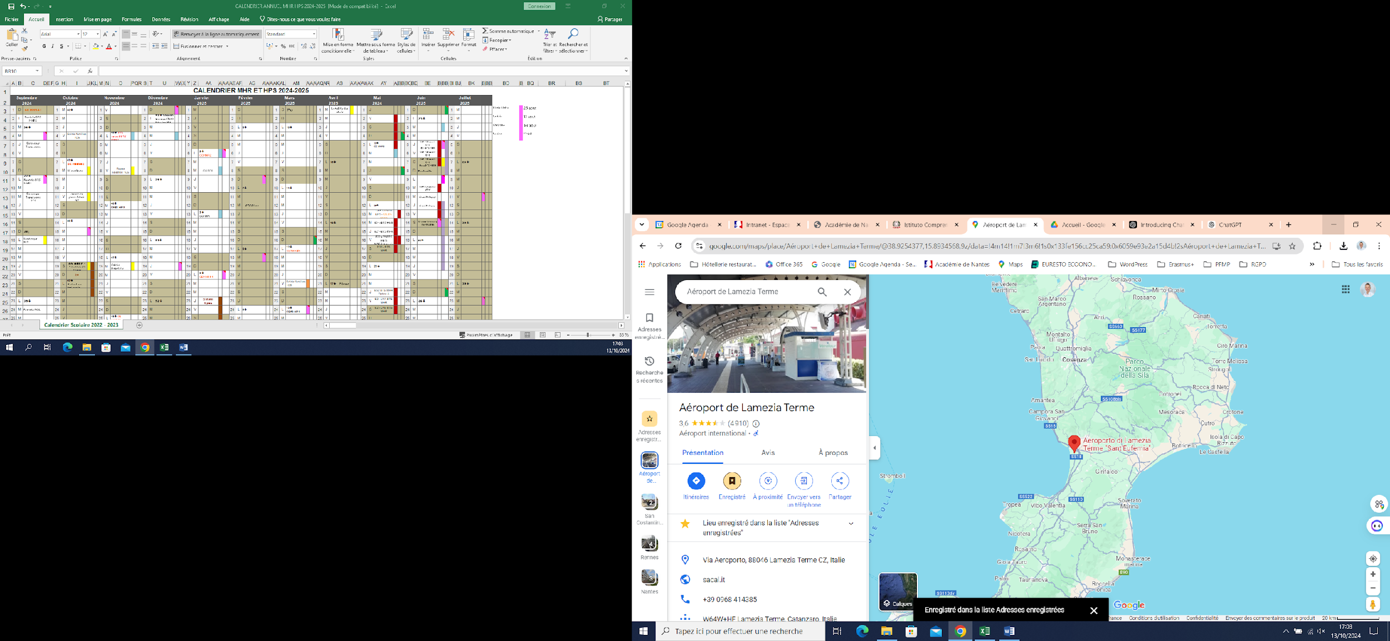 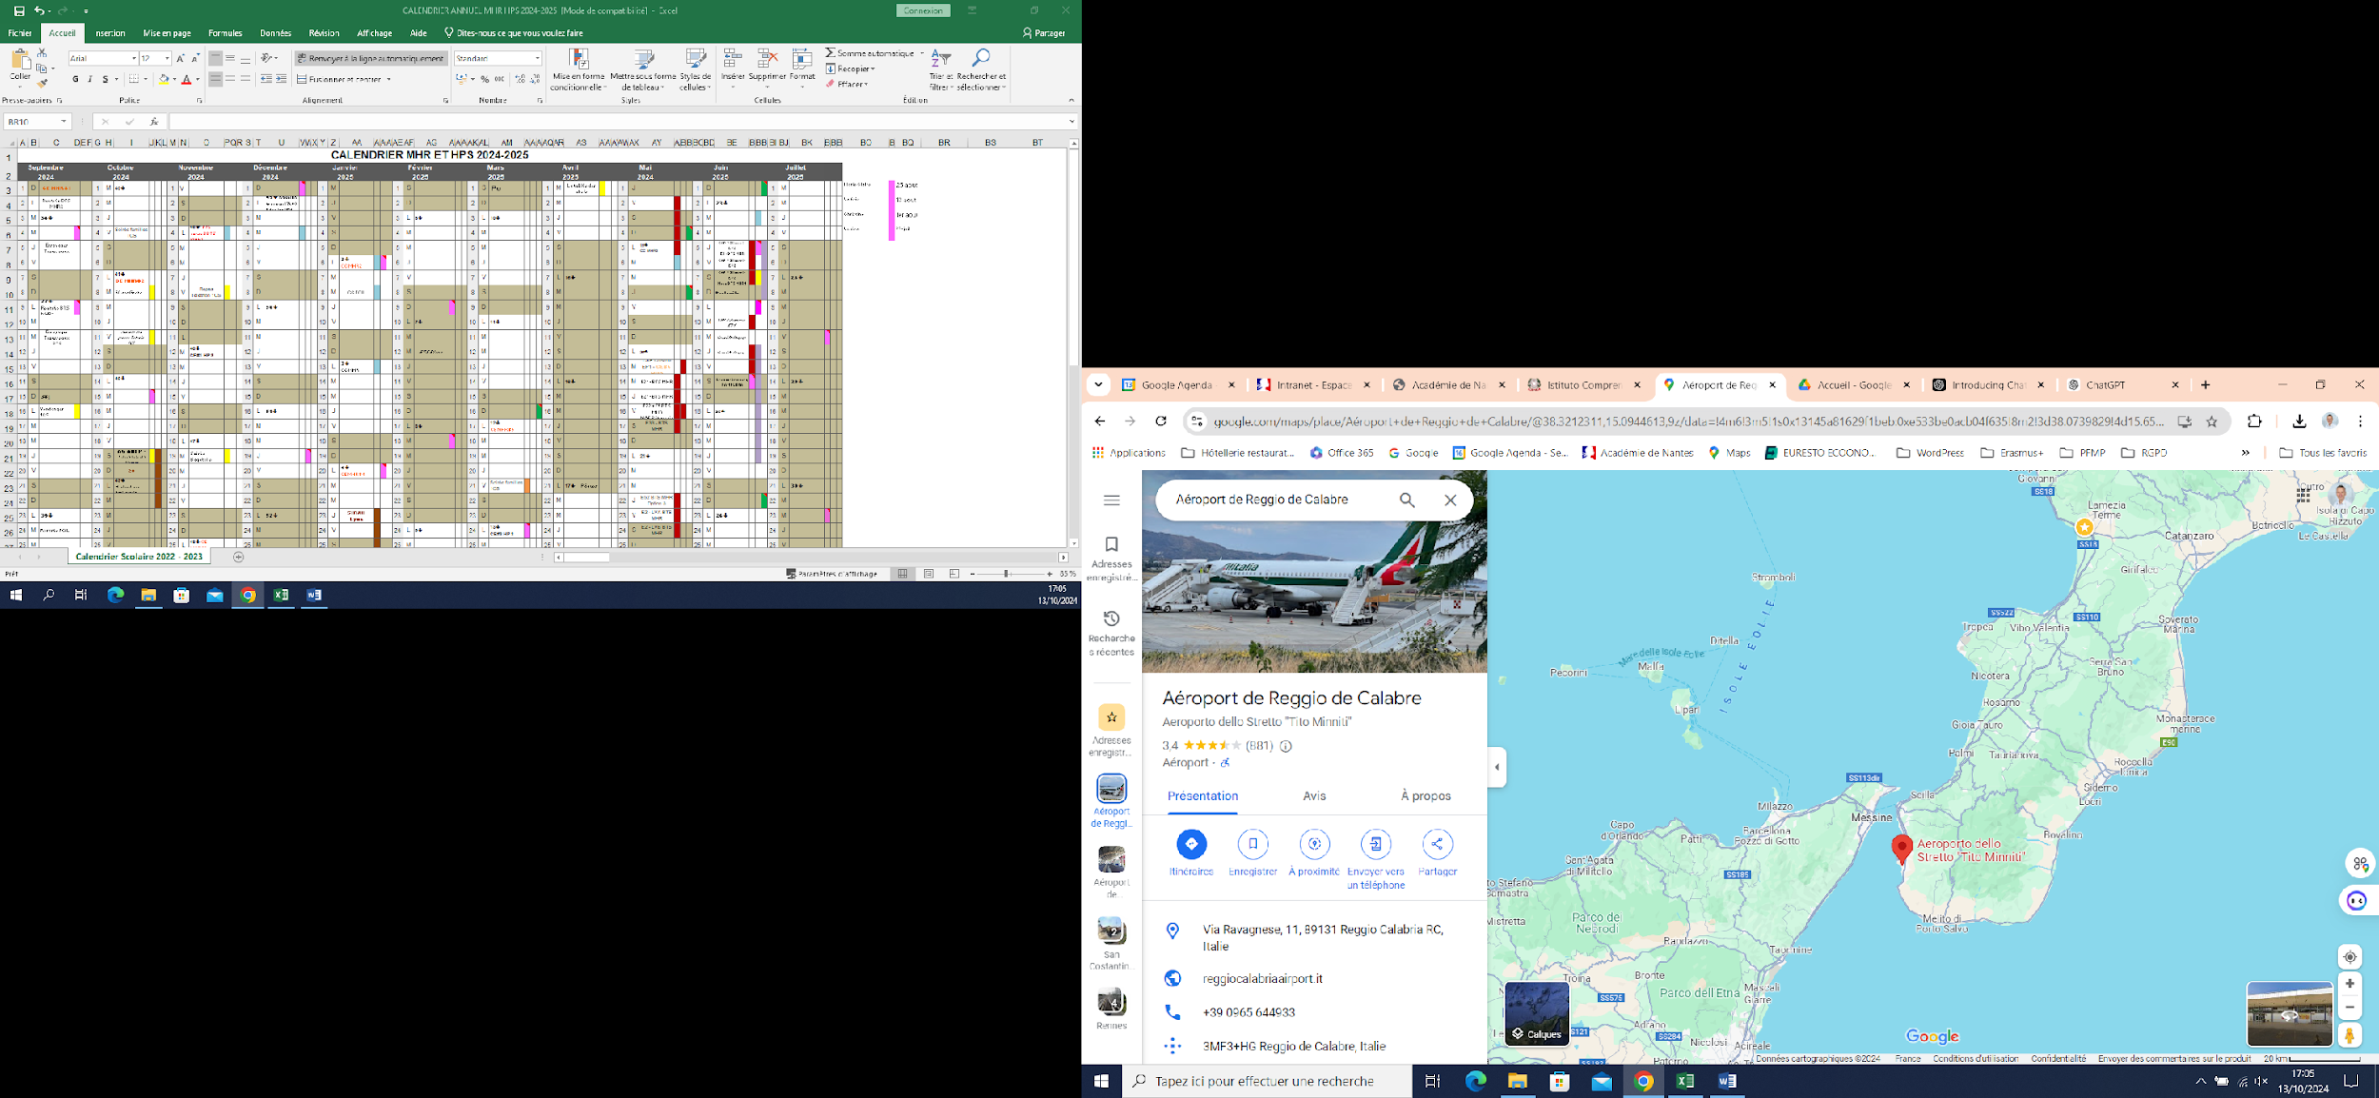

**Train station**: Vibo Valentia Pizzo (15 kilomèters), Lamezia Terme (30 kilometers).

|  |  |
| --- | --- |
| **Thursday - Day 1 - 26th of June**  **10:00 - Welcome and "Breakfast from Europe"** Location: school room or caffè ➧ Equipment: PC, video, paper board, pencils, paper. ➧ ChatGPT-generated poster. Discover local and international specialties: each partner brings typical biscuits from their country. Coffee break arranged from10:00 to 10:30 at school.  Short **Guided Tour of San Constantino Calabro**  **11:00 - School introduction and** Led by students and Luisa Vitale, the headmaster of the school. Languages: (French and English).  Pedagogical specificities of the Italian education system in a European context  Presentation of the institute by the management : pedagogical organization of the institute, the role of international openness in the programs, the challenges encountered.  **12:00 - Introduction to the Seminar** Location: Erasmus+ Partners room Eduardo and Guillaume will present the seminar's philosophy, its origins, and future perspectives.  Round of introduction for partners:  **Presenting one’s organization:** Rely on examples of projects related to international openness to highlight the pedagogical specificities of each country.  **Comparing different educational systems in Europe:** France, Spain, and Italy. Understand the administrative and pedagogical constraints involved in implementing Erasmus+ programs.  **12:30 - Workshop Preparation** Finalize the presentations for partners. Adjust program details and prepare workshops. Exchange and peer collaboration to finalize the workshops to be offered to participants. Sharing best practices, brainstorming, constructing or finalizing presentations.  13:00 Short Lunch  **13:30 - Practical training - Snorkl** <https://snorkl.app/>  Snorkl is a multimodal AI tool for the classroom. Supercharge learning with high quality feedback on students’ verbal and visual explanations.  We will draw on the expertise of Jon Laven, CEO of Snorkl, for a pedagogical demonstration of the tool, in the presence of teachers from primary to secondary levels. [Episode 268: Snorkl](https://youtu.be/E5REfZEfsbE)  **14:30- Donatella Bruni** (English teacher and Erasmus coordinator at the Linguisticc High School of Vibo Valentia) presents her experience as an Erasmus coordinator.  **15.00- Maria Lorenza Campanella** (English teacher and Erasmus coordinator at the Scientific High School of Vibo Valentia) presents her experience as an Erasmus coordinator.  **15.30 Practical training - Etwinning platform:** Built and Etwinning space regarding the seminary.  Caterina will present the possibilities offered by eTwinning and then propose the design of a TwinSpace for teachers. The created TwinSpace will serve as a dissemination platform for the seminar’s activities. Each participant will contribute to the space by uploading their work from the proposed workshops.  **16:00 - Practical training - Edpuzzle https://edpuzzle.com/**  EDpuzzle is a web-based eLearning application allowing users to select a video and customize it by editing, cropping, recording their own audio, and adding quiz questions directly to the video stream. EDpuzzle also allows for instructors to track, monitor, and grade students engagement with the videos created.  **17:00 - Practical training - Class in the box** <https://classinthebox.io/login/web>  Transform video & text into interactive learning adventures · Integrated Artificial Intelligence · Automatic question generation · Instant feedback for students  **18:00 Smile and Learn- Ainara**  Discover the full potential of this all-in-one generative AI, created by and for educators. With AInara you can create and use quality teaching resources that are rigorous and appropriate.  Ainara helps to create, with great quality and in a very short time, expository and evaluative educational resources for all stages, as well as to customize those resources to the different educational needs in an incredible way. It also allows you to generate resources for hybrid learning, to be used both on paper and in multimedia digital media, all in a safe and simple way.  **App:** [**https://app.ainara.io/login**](https://app.ainara.io/login)  **Web information:** [**www.ainara.education**](http://www.ainara.education)  Artificial Intelligence · Automatic question generation · Instant feedback for students  Images Audiobooks · Motivational Learning · Corpus of Smile and Learn  **19:00 Padlet** [**www.padlet.com**](http://www.padlet.com)  **Zareen**  **Link to the videocall:** [**https://padlet.zoom.us/j/81729926863?pwd=zch2PygrKJswNAbKFA1scp4SbpEx9p.1&jst=2**](https://padlet.zoom.us/j/81729926863?pwd=zch2PygrKJswNAbKFA1scp4SbpEx9p.1&jst=2) | **Friday - Day 2 - 27Th of june**  **9:00-10:30 - Teacher-Student Testimonial Sessions** Location: Partners room. Partners, students, and teachers share their Erasmus+ experiences. ➧ 6 Italian students from San Costantino Calabro share their mobility experiences.  ➧Tiziana Rubino (French teacher and Erasmus coordinator of I.C. San Costantino Calabro) and other Italian teachers of I.C. San Costantino Calabro-Mileto present their Erasmus+ job-shadowing experience.  **10:30 – Break**  **11.00 - Teachers Testimonial Sessions**  **11.00-11.30**  Short meetings, partnerships, and projects to teachers who wish to develop exchanges. Workshop in the form of round tables where participants meet the Erasmus+ coordinators from the present countries. ➧Partner "speed-dating" session for collaboration with Italian teachers from the area.  **12:00 - European Language Labels Prices**  Présentation of 3 european language labels prices  **12:30 Practical training - AI And CANVA Session**, by Eduardo Rubio and Students.  ➧ **AI and Erasmus+ Management** by Eduardo Rubio. Application CANVA with young students and teachers in reality.  **A pedagogical session using Canva with Italian students in a foreign language context.** Starting with a small sample group of Italian students, the aim is to demonstrate the potential of using Canva without specific lesson preparation, by relying on AI features integrated into the platform.  **14:00 - Lunch**  **17:00 Practical training - Minecraft with Letcraft**  **18:00 Practical training - prompt with canvassador and Khalid, ingénieur**  **pedagogique**  **“Crée le prompt parfait pour tes projets”**  **21:00 - Dinner at a Local Restaurant** Enjoy regional Italian cuisine. |

|  |
| --- |
| **Saturday – Day 3 - 28 Th of june**  **9:00-14:00**  **Workshops for Partners** Location: Partners' room. Focus on Erasmus+ management and experiences with practical solutions: Beneficiary module, AI integration in program management, volunteering, and digital tools  **Well-being in Erasmus+ Management** Open dialogue on challenges and successes in organizing Erasmus+ programs.  Design an activity that allows each participant to present a constraint or issue related to Erasmus+ programs and to identify actions to be implemented in order to improve their functioning.  We would be delighted to invite a representative from the Erasmus+ agency in the Calabria region to take part in two key activities: the Erasmus+ ceremony and a session focused on well-being in the coordination of Erasmus+ programs.  **Break 10:30 or 11:00**  **Erasmus+ Management**  ➧ **Learner mobility in higher education:** What are the prospects for primary and secondary school students in continuing their studies? By Margaret Stanley, Erasmus+ coordinator at the high school Livet, in Nantes (France).  ➧ Practical training on using the Beneficiary Module if asking.  ➧ **Feedback and new perspectives from partners** (partnerships). **How to consolidate partnerships abroad. What strategy to deploy to retain partners?**  Encourage the hosting of groups and job shadowing within your own organization, and involve your teams to promote international openness. Rely on institutional organizations for support (consortiums, eTwinning network, etc.).  ➧  **Seminar Conclusion**  **14:00 lunch et personal activity**  **Resources:** <https://padlet.com/zap9/JunePD>  **Examples:** <https://padlet.com/zap9/june>  **AI Drawing** Tool: <https://padlet.com/zap9/draw3>  **AI examples:** <https://padlet.com/ZAPSchool/magic>  **Padlet Webinar Sessions:** <https://padlet.link/sessions>  Grid it’s the good model to organize our padlets  **Synthèse de l’atelier:** **How could teachers’ pedagogical skills potentially be affected by these tools?** |
| **Sunday – Day 4 - 29 Th of june**  Cultural and gastronomic Activity  **Cultural Visit to Tropea or Vibo Valentia** Explore the cultural heritage of the region, focusing on the stunning coastal city of Tropea or the historical sites of Vibo Valentia.  Focusing also on typical food. |

|  |  |  |
| --- | --- | --- |
| **WORKSHOPS** | | |
| **DAY 1 Thursday 26/06/25** | **DAY 2 Friday 27/06/25** | **DAY 3 Saturday 28/06/25** |
| ISTITUTO COMPRESIVO E. PUGLIESE 12:00  **INTRODUCTION**  By Luisa Vitale (headmaster) and Tiziana Rubino, Erasmus+ coordinator | ISTITUTO COMPRESIVO E. PUGLIESE 9:00 am to 10:30  **TESTIMONIAL SESSION**  By Tiziana Rubino, Erasmus+ coordinator, Students and teachers beneficiary Erasmus+ Programs | WORKSHOP 9:00 am  **DEVELOP PARTNERSHIPS**  By Guillaume Delhommeau, Erasmus coordinator |
| PRACTICAL TRAINING 13:30 pm  **SNORKL**  By Jon Laven - CEO of Snorkl | ROUND TABLE and MEETING 10:30 - 11:00  **PARTNERS AND ERASMUS+ DATING**  **TESTIMONIAL SESSION**  **Stong women will build the future: e European Language Label Success Story**  By Arianna Sturniolo | ERASMUS+ MANAGEMENT 9:45 am  **WELL BEEING IN ERASMUS+ MANAGEMENT**  By Guillaume Delhommeau and Eduardo Rubio, Erasmus+ coordinators |
| PRACTICAL TRAINING 11:00 - 12:00  **Présentation Lycée scientifique et linguistique Italie**  11.00-12.00 Maria Lorenza Campanella and Donatella Bruni | PRACTICAL TRAINING 14:00 -15:00  **ETWINNING PLATFORM**  By Caterina Mazzuca, Erasmus+ and Etwinning coordinator | WORKSHOP 10:30 am  **BENEFICIARY MODULE** |
| PEDAGOGICAL WORKSHOP 16:00 pm  **EDPUZZLE**  By Jesús Sánchez (community manager Edpuzzle).. | TESTIMONIAL SESSION 12:00 am  **ERASMUS+ EUROPEAN LANGUAGE LABELS**  By María del Mar Cordero, Eduardo Rubio and other italian school: winners of this price | WORKSHOP 11:15 am  **MOBILITY IN HIGHER EDUCATION**  By Margaret Stanley, Erasmus+ coordinator |
| WORKSHOP 17:00 pm  **CLASS IN THE BOX**  By Pablo Marquez (CEO Class in the box) (CEO Class in the box) | 13:00 - 14h00  **PRACTICAL TRAINING-AI AND CANVA SESSION**  By Eduardo Rubio and students (6 élèves) | ERASMUS+ MANAGEMENT 12:00 am  **SUMMARY AND CONCLUSION**  By Guillaume Delhommeau and Eduardo Rubio, Erasmus+ coordinators |
| WORKSHOP 18:00 pm  **SMILE AND LEARN**  By Ainara | PEDAGOGICAL WORKSHOP 17:00 pm  **MINECRAFT EDUCATION** |  |
| PEDAGOGICAL WORKSHOP 19:00 pm le jeudi  **PADLET**  By Zaareen  Link to the videocall: <https://padlet.zoom.us/j/81729926863?pwd=zch2PygrKJswNAbKFA1scp4SbpEx9p.1&jst=2> | PEDAGOGICAL WORKSHOP - 18:00 pm  **WRITE AN IA PROMPT**  By Khalid, pedagogical ingénieur | **DAY 4 Sunday**  **CULTURAL AND PERSONAL ACTIVITIES**  These activities are not part of the seminar program |
|  |  |  |
| INSTITUTIONAL ACTIVITY | PEDAGOGICAL ACTIVITY | ERASMUS MANAGEMENT |

**"Exchanging best practices in Erasmus+ program management - upgrading partners' skills" - From 26th to 28th of June 2025.**

**Erasmus+ Partner Seminary final PROGRAM**

**PROGRAMME ERASMUS+ / JOB SHADOWING - Projet n° / Project n° :**

|  |  |  |
| --- | --- | --- |
| **Day** | **Hour** | **Activity** |
| **1** | 9:00 | **Welcome** – European Breakfast in Italy |
| 9:30 | School Introduction – Italian educational organisation and Pedagogical specificities of the Italian education system in a European context |
| 10:30 | **Break** |
| 11:00 | **Introduction to the Seminar -** Round of introduction for partners:  Presenting **one’s organization** and comparing different **educational systems in Europe.** |
| 11:30 | **Workshop Preparation**  - Exchange and peer collaboration to finalize the workshops to be offered to participants. Sharing best practices, brainstorming, constructing or finalizing presentations. |
| 12 :30 | **Practical training - Etwinning platform:** Built and Etwinning space regarding the seminary. |
| 13:30 | **Practical training - Snorkl - Ed Puzzle and Class in the box** |
| 18:00 | End |
| **2** | 9:00 | **Teacher-Student Testimonial Sessions :** Italian students about their mobility, Teachers present Etwinning Project and job shadowing |
| 10:30 | **Break** |
| 11:00 | **Erasmus+ dating :** Partner "speed-dating" session for collaboration with Italian teachers from the area. |
| 12:00 | Erasmus+ Ceremony – **Forum and conference** |
| 13:30 | Well-being in **Erasmus+ Management** |
| 15:00 | End |
| **3** | 9:00 | **Workshops for Partners** |
| 9:00 | **AI and Erasmus+ Management** by Eduardo Rubio. Application CANVA IA |
| 10:30 | **Break** |
| 11:00 | Write an IA prompt |
| 12:00 | **Pedagogical Workshops,** Featuring tools Edpuzzle, Class in Box, and Padlet. Presentation and hands-on workshops. |
| 13:00 | **Erasmus+ Management** |
| 13:30 | **Learner mobility in higher education:** |
| 14:30 | Practical training on using the Beneficiary Module |
| 15:30 | **Feedback and new perspectives from partners** |
| 16:30 | **Seminar Conclusion** |

Istituto Comprensivo

**E. Pugliese**

**San Costantino Calabro** – Mileto

**CONTACTS**

|  |  |
| --- | --- |
| **Luisa Vitale**  Principal  **M** (+39)3387350741  **W** <https://www.icsancostantino.edu.it/>  **E** luisa.vitale@icsancostantino.edu.it  **A** [Via CA dalla Chiesa - San Costantino Calabro](https://www.google.com/maps/search/Via%20C.%20A.%20dalla%20Chiesa%20-%20San%20Costantino%20Calabro) - Italia | **Tiziana Rubino**  Erasmus+ coordinator  **M** (+39)3476244619  **W** <https://www.icsancostantino.edu.it/>  **E** tizianarubino72@gmail.com  **A** [Via CA dalla Chiesa - San Costantino Calabro](https://www.google.com/maps/search/Via%20C.%20A.%20dalla%20Chiesa%20-%20San%20Costantino%20Calabro) - Italia |
| **Eduardo Rubio Nubla**  Coordinador Erasmus+ Colegio Nuestra Señora del Huerto  **P +34 659621311**  **W** [https://www.colegionshuertopamplona.com](https://www.colegionshuertopamplona.com/)  **E** eduardorubio@nshuerto.org  **E** coordinadorerasmusplus@nshuerto.org  **A** C. del Monasterio de Urdax, 25, 31011 Pamplona, España | **Guillaume Delhommeau**  Directeur Délégué aux Formations professionnelle**s**  **M +33 684 196 968**  **W** <https://funay-boucher.paysdelaloire.e-lyco.fr/>  **E** guillaume.delhommeau@ac-nantes.fr  **A 22** Rue Rodolphe Diesel, 72100 Le Mans - France |

**WHATSAPP LINK**

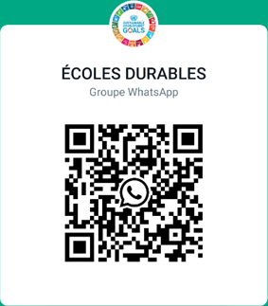

**Participants, Partners, schools or organizations 2025**

|  |  |  |  |  |
| --- | --- | --- | --- | --- |
| **Participant/ Partenaires** | **Ecole représentée ou organisation** | **Mail adress** | **Phone Number** |  |
| Guillaume Delhommeau | Lycée Professionnel Funay Hélène Boucher | guillaume.delhommeau@ac-nantes.fr | +336 84 19 69 68 |  |
| Eduardo Rubio | Colegio Nuestra Señora del Huerto | eduardorubio@nshuerto.org | +346 59 62 13 11 |  |
| María del Mar Cordero Sánchez | IES Jabalcuz | mmar.corderos@iesjabalcuz.es | +34 607 59 35 28 |  |
| María Irene Gallego Alcalá | IES Jabalcuz | irene.gallegoa@iesjabalcuz.es | +34 636 36 04 00 |  |
| Caterina Mazzuca |  | caterinamazzuca@gmail.com |  |  |
| Margaret Stanley | Lycée Livet | margaret.stanley@ac-nantes.fr | +336 4404 1836 |  |
| Luisa Vitale | I.C. San Costantino Calabro-Mileto | luisa.vitale@icsancostantino.edu.it | +393387350741 |  |
| Tiziana Rubino | I.C. San Costantino Calabro-Mileto | tizianarubino72@gmail.com | +393476244619 |  |
| Donatella Bruni | Liceo Statale Vito Capialbi Vibo Valentia |  |  |  |
| Maria Lorenza Campanella | Liceo Scientifico Giuseppe Berto Vibo Valentia |  |  |  |
| Francesca Meligrana | IPSEOA Gagliardi IIS De Filippis Prestia Vibo Valentia |  |  |  |